**1 Mar 2019** **The Weekly Bulletin of Rotary Club of Kathmandu Mid-Town** **bc-23.3/019**

|  |
| --- |
| C:\Users\Public\Documents\RIP T1819_EN.png |

District: 3292 Web:www.rotarymidtown.org.np Club Id: 26776

**MARCH IS WATER AND SANITATION** **MONTH**

Rotarians in India have responded to a call for action by Prime Minister Narendra Modi to participate in the national campaign, ‘Swachh Bharat Abhiyaan’. Rotary clubs throughout India have aligned their efforts to participate in this campaign, committing to provide comprehensive water sanitation and hygiene coverage in at least 10,000 government schools, every year, for at least two years.

**Club’s Weekly Meeting # 1478 held on Friday 22 Feb 2019**

Guest speaker Dr Richard Howard talked about his experiences in Asian countries and how ILO helping in Nepal on labour right, women right, and on issues such as child labour, gender equality, working hours, living conditions, labour safety, health, trafficking etc.

**Club Meeting # 1479 Friday 1 Mar**

Ms Bina Pradhan will be giving a presentation on Nuwakot Livelihood Coffee Project, also known as “Women’s Expanded Coffee Production and Marketing Project” Nuwakot.

She is the project manager.

**11th District Conference,Butwal**

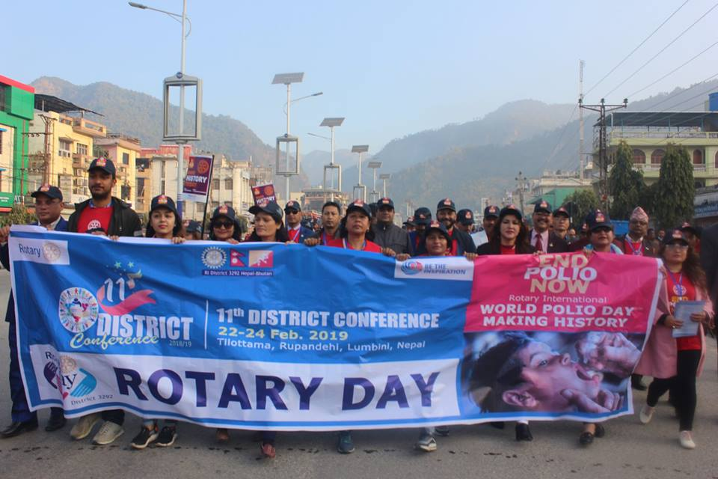

11th District Conference of RIDistrict 3292 was held recently in Butwal, Gandaki Pradesh. Congratulations to all involved in organizing such a great event very successfully.

**Site Visit Mangal School, Kirtipur:**

Youth Service chair PP Dr Chandra Lekha Tuladhar, along with 3 Rotaracts, visited two of SAP schools and the day care center at Kirtipur on Tuesday 3 Feb for overseeing progress of different projects. She also handed over carpet strips, received from Rotarian Dr Sanjeevan, to Kirtipur Mangal School during the occasion. The carpet strips are for use for small school children during meal time.

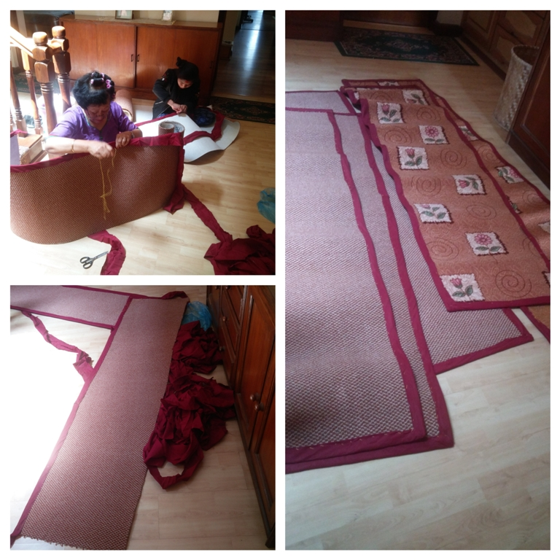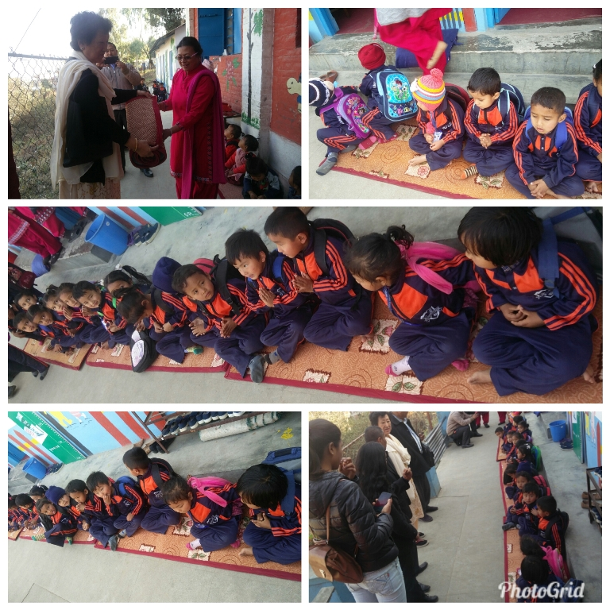

**Inducted in the Hall of Fame:**

Rotarian Gen Krishna NS Thapa was inducted in the Hall of Fame in Birendra Peace Operation Center in Panchkhal on Friday 22 Feb 2019 for honouring him being the first Nepalese General Officer to Command the UN Peace Mission as Force Commander at the rank of ASG of United Nations. **Congratulations!**

**Do you Know** **?**

Delhi could be the world’s most populous city by 2028. Already, India’s capital city is the world’s second most populous urban agglomeration. The future is even more frightening: a United Nations report released in mid-2018 says Delhi could be the world’s most populous city by 2028 with 37.2 million people. That is eight million more in just 10 years. Politics and pollution keep Delhi forever in the news, now another P, that is, population growth will be more soaring.

*Read more on Economic Times*

**A THOUGHT FOR THE DAY**

[It is time that women take the onus upon themselves to instill in their daughters and much more, their sons, that a daughter is as valuable, if not more, as a son and has to be treated so.](http://www.brainyquote.com/quotes/quotes/g/georgewash106292.html)

*Rasheeda Bhagat, Rotary News May 2018*

On Lighter Side:

A new blonde employee calls the Help Desk to complain that there's something wrong with her password. “No, it's not the usual caps-lock problem.”

“The problem is that whenever I type the password, it just shows stars," she says.

"Those asterisks are to protect you," the Help Desk technician explains, "so if someone were standing behind you, they wouldn't be able to read your password."

"Yeah," she says, "but they show up even when there is no one standing behind me."!

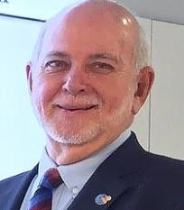

I want to see Rotary Be the Inspiration for our communities through work with a

transformational impact — taking the time to research the real needs, to involve all the

participants, to plan and to partner.

**RI President Barry Rassin**

Please send information on club activities, progress reviews on service projects, relevant photos etc to:

BC Editor: RR Shrestha email: rryesrr@gmail.com

## 1 Mar 2019 The Weekly Bulletin of Rotary Club of Kathmandu Mid-Town bc-23.3/019